Salesforce

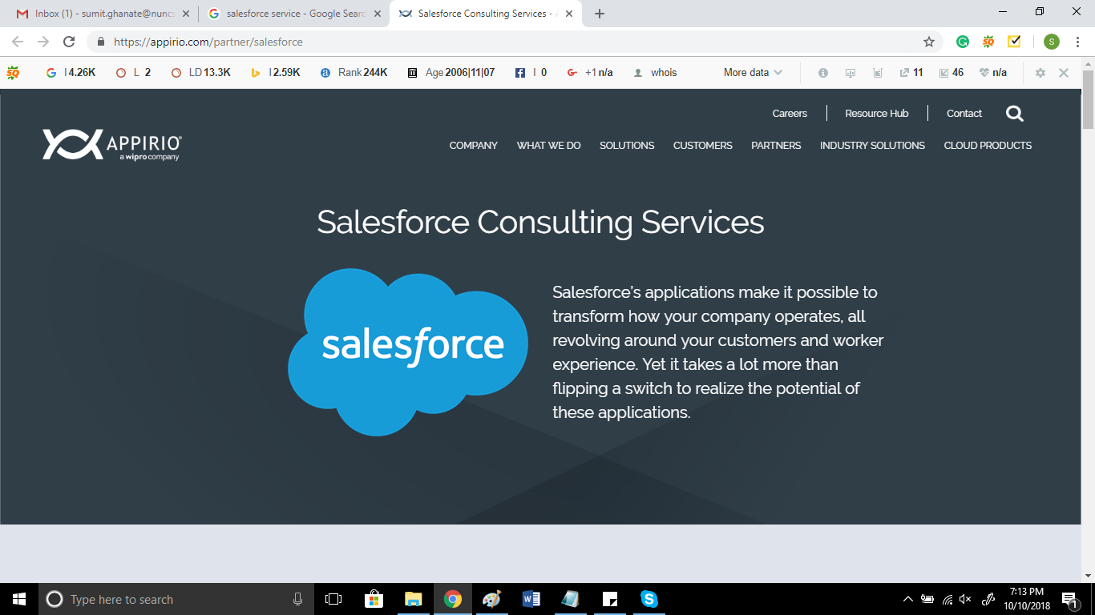

**Text to be replaced**

Salesforce Services

Salesforce is an innovative application that enables organizations to reimagine their relationships with customers from a new view across all networks and at every touch point. Salesforce’s CRM solution put the customer at the center of everything they do.

**Next>>**

We as a Salesforce development company help companies in planning, designing and implementing complete Salesforce business solutions. We change the way companies interact and manage their customers, products, partners, and even employees. We employ our clients in finding the right Salesforce product, the right feature set, and the right customizations. We are here to set the full potential for you.

We are a team of expert in evaluating your work practices and providing the essential consultation. Our effort is to bring forth the possibilities to build lasting relationships between you and your clients. With the help of Salesforce you can create a legacy worth remembering.

**Next>>**

**Salesforce Implementation Consulting**

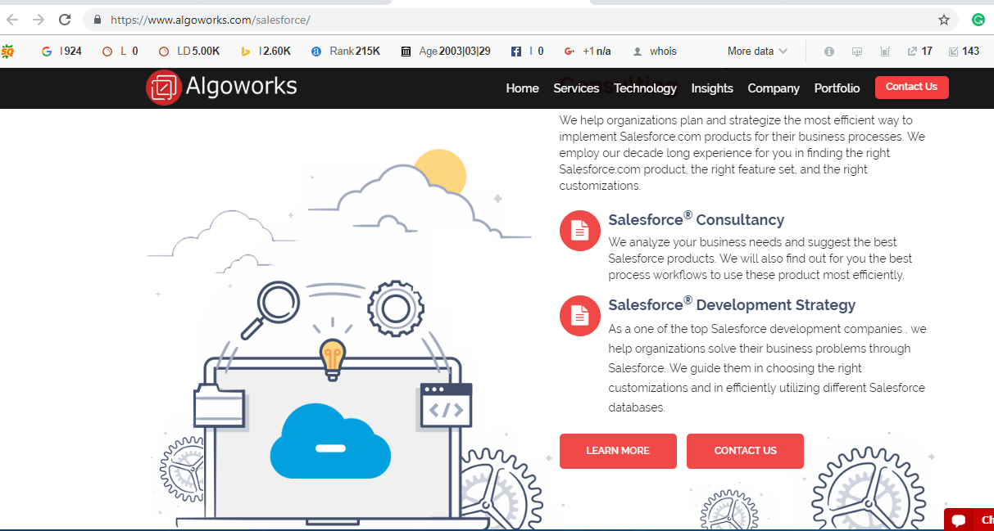

Text to be used

**Salesforce Consulting**

Nunc Systems help companies design and plan the most effective way to implement Salesforce products for their business. Our expert professional help our clients to find the right Salesforce product.

**Salesforce Development Strategy**

Nunc Systems help organizations solve their business problems through Salesforce. We guide them in choosing the correct customizations and in efficiently using different Salesforce databases.

Next>>

**Our Salesforce Development Services**

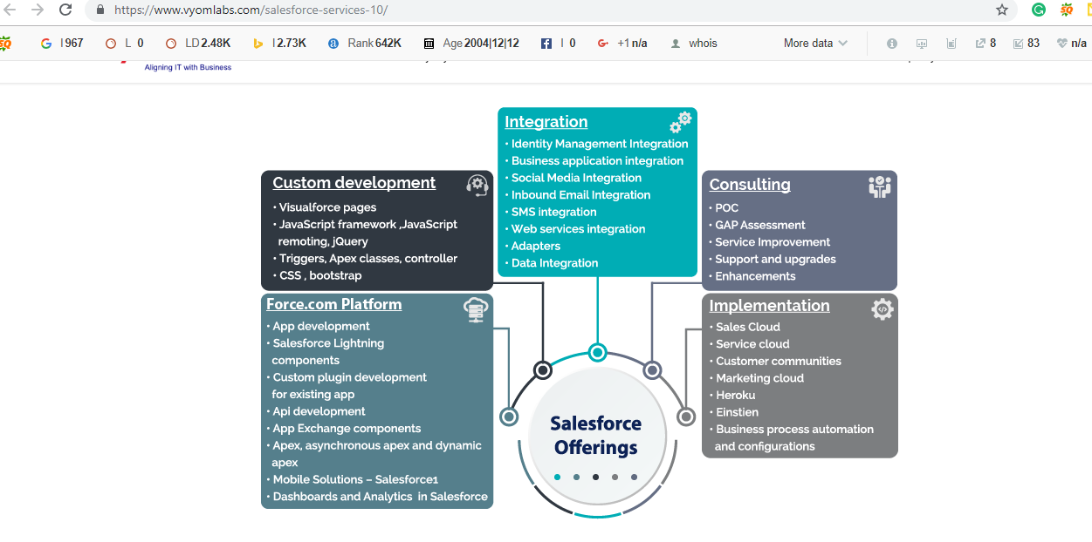

**Next>>**

**Our Implementation Approach**

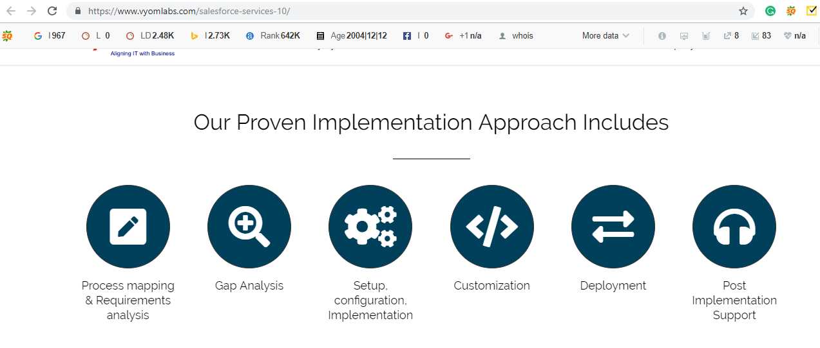

**Next>>**

